1Basic navigation and symbols cheat sheet 🡪 

Controlling CO cheat sheet 🡪 

Finance FI cheat sheet 🡪 

Fiori cheat sheet 🡪 

ABAP cheat sheet 🡪 

SD cheat sheet 🡪 

MM cheat sheet 🡪 

* More information about Hana in-memory OLAP/OLTP by Hasso Plattner 🡪 <http://s-prs.co/v485708>

**t-codes used in ECC which are deprecated in S/4 Hana**

t-code SE16 table PRGN_CORR2 – on the left deprecated.

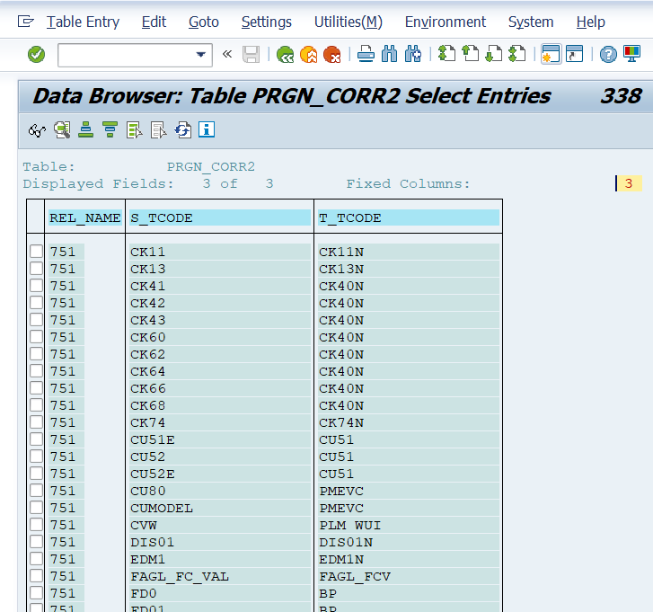

Parameters to use in t-code SU3

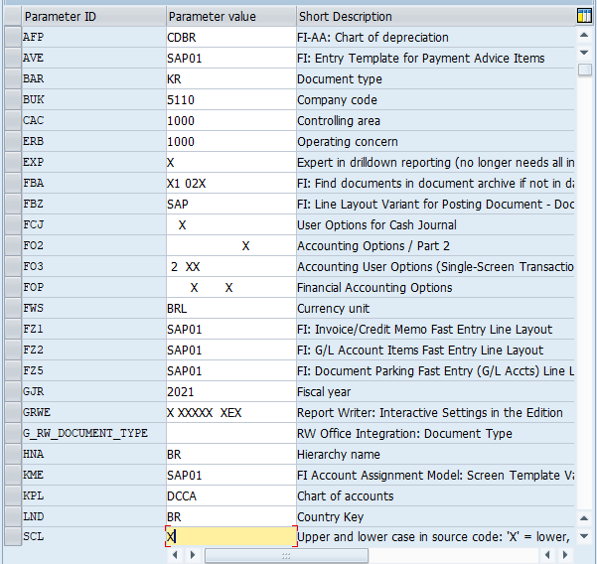

Fiori Apps List

[SAP Fiori List](https://fioriappslibrary.hana.ondemand.com/sap/fix/externalViewer/)

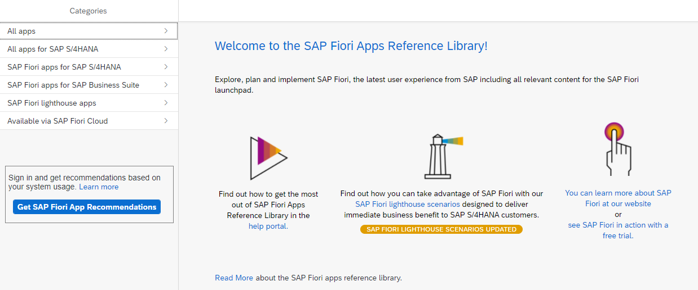

**Activities IMG – Transactions Configuration Tree**

ORFA – Asset Accounting

FAGL_FLEXGL_IMG – Financial Accounting

GLFLEXIMG – New GL

FOAR00 – Task Menu

SUIM – User Information System

* Go to table TSTC and on field Program = *IMG* for consultants
* Go to table TSTC and on field Program = *menu* for users
* Another way is table TSTCT (transactions text) and table TSTCP (transactions parameters) where can be search by t-code SM30 or by table.
* To create your own Menu Are go to t-code SE43 – Search for *00* *MN* for more t-codes

**User Menus**

SAP1 – All reports - disseminate

ASMN – Asset Accounting

FIAA – Asset Accounting Information

FDMN – Customer Accounting

FKMN – Vendors Accounting

F000 –Financial Accounting ]

ORK0 – General Controlling

ORKL – Cost and Revenue Element Accounting Controlling

FGM0 – Special Purpose Ledger

OLME – Purchasing Customizing

CKML – Actual Costing / Material Ledger

FGRW – Report Writer

SISU – Industrial Solution – Utilities

PC37 – Payroll Brazil

ME00 – Purchasing

WEKF – Purchase Order

WL00 – Vendors

BUPT – Business Partner

W10E – Goods Receipt

MRM0 – Invoice Verification / MCB1 – Inventory Controlling

SAP1 – all reports in SAP

CX01 – ECCS/EC-CS module

Questions for a new SAP project or enhancement

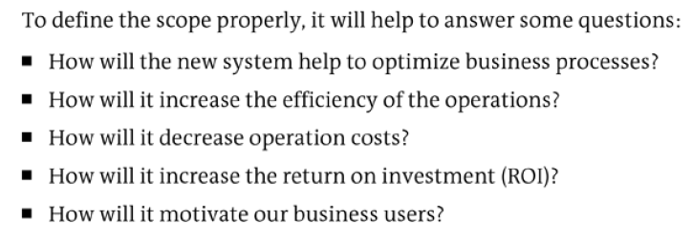

Pros and Cons – Project S/4Hana

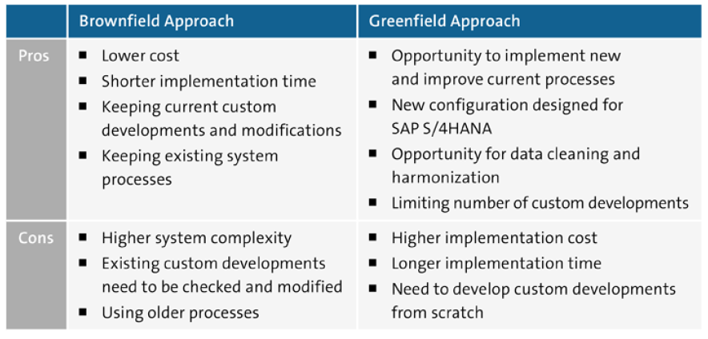

Table ACDOCA

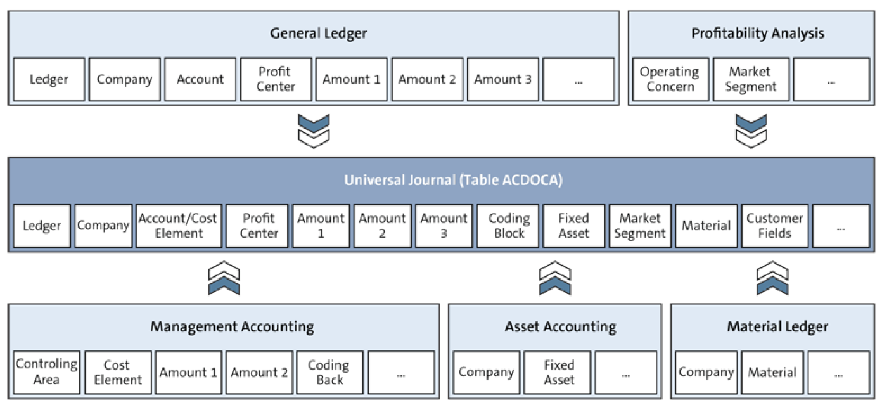

Obsolete tables – exist in S/4Hana only for compatibility reasons as CDS views (core data services)

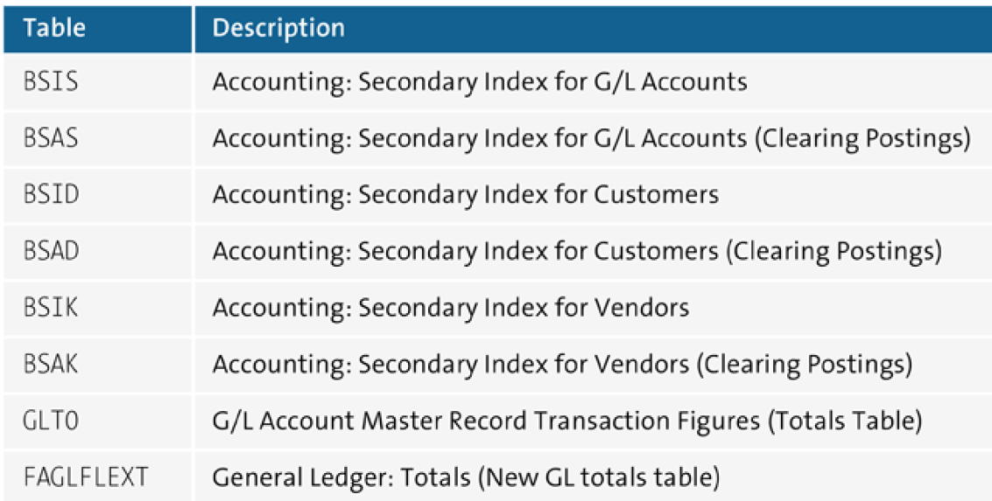

Company Codes for my study – client 400 – best practices

2520 – Canada Company

2530 – USA Company

2540 – Brazil Company

I have problems when creating CC 2520 and SAP Help recommended me t-code FINS_CUST_CONS_CHK and FINS_CUST_CONS_CHK_P to check consistency in company codes.

**Manual insert in table**

To verify if there is any manual addition to a table run report RKSE16N_CD_DISPLAY on t-code SE38 for changes in a table.

Note report RKSE16N_CD_SHOW_DELETE (0bsolete on Hana check SAP Note 1360465)

Transaction SEARCH_SAP_MENU

T-code that helps to find other transactions, just the transaction, enter the word and SAP will bring every transaction with that name.

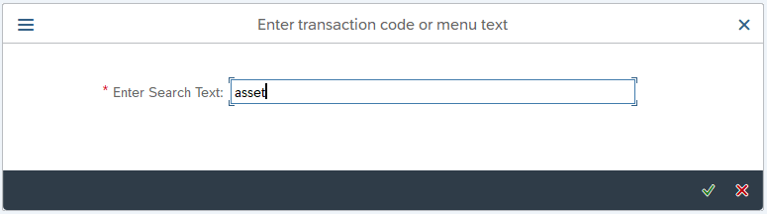

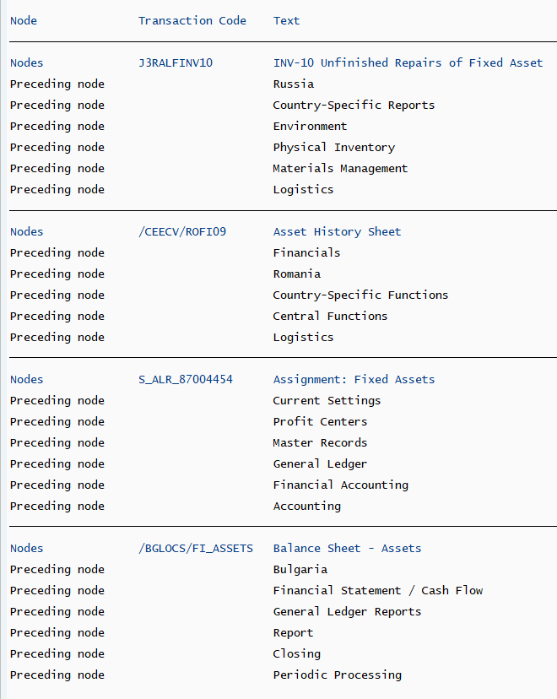

SAP on azure – Study

<https://blogs.sap.com/2021/02/06/get-certified-microsoft-certified-azure-for-sap-workloads-specialy/>

<https://docs.microsoft.com/en-us/learn/certifications/azure-for-sap-workloads-specialty/>

<https://github.com/Azure/sap-hana>

### SAP Notes

The SAP Workloads documentation from Microsoft references several SAP support notes, some of which you might want to read carefully and bookmark.

* [1928533 – SAP Applications on Azure: Supported Products and Azure VM types](https://launchpad.support.sap.com/#/notes/1928533)
* [2015553 – SAP on Microsoft Azure: Support prerequisites](https://launchpad.support.sap.com/#/notes/2015553)
* [2513384 – SUSE Linux Enterprise Server for SAP Applications on Azure](https://launchpad.support.sap.com/#/notes/2513384)
* [2694118 – Red Hat Enterprise Linux HA Add-On on Azure](https://launchpad.support.sap.com/#/notes/2694118)
* [1409604 – Virtualization on Windows: Enhanced monitoring](https://launchpad.support.sap.com/#/notes/1409604)

Books so far

* [SAP on Microsoft Azure Architecture and Administration](https://www.sap-press.com/sap-on-microsoft-azure_5174/) by [Ravi Kashyap](https://linkedin.kashyap.one/) [SAP PRESS]
* [SAP on Azure Implementation Guide](https://www.packtpub.com/product/sap-on-azure-implementation-guide/9781838983987) by [Bartosz Jarkowski](https://people.sap.com/bartosz.jarkowski4) and Nick Morgan [Packt]

OpenText VIM – Vendor Invoice Management

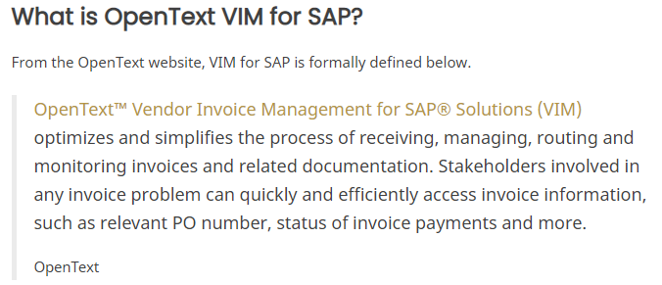

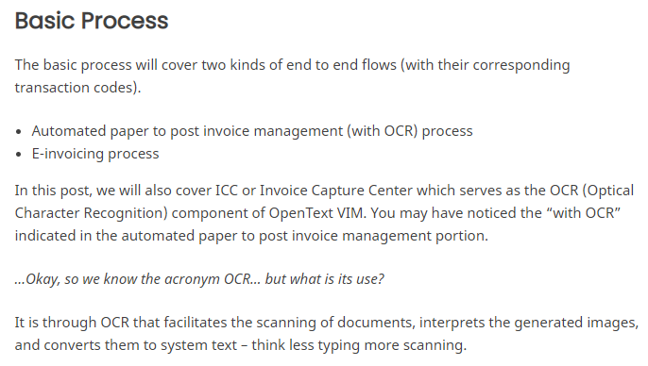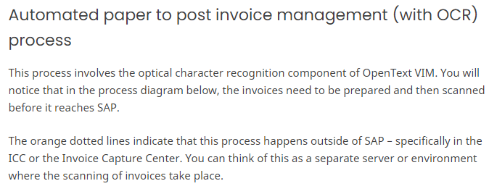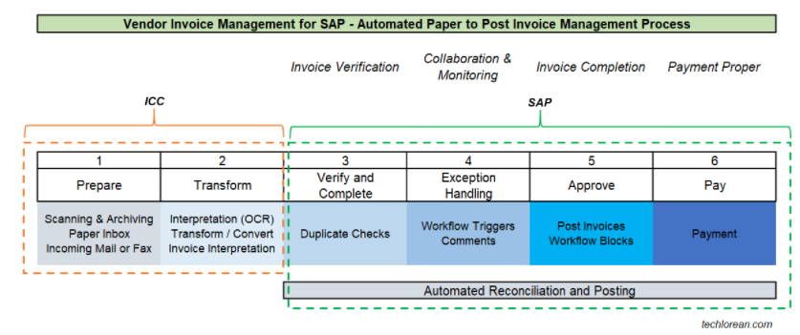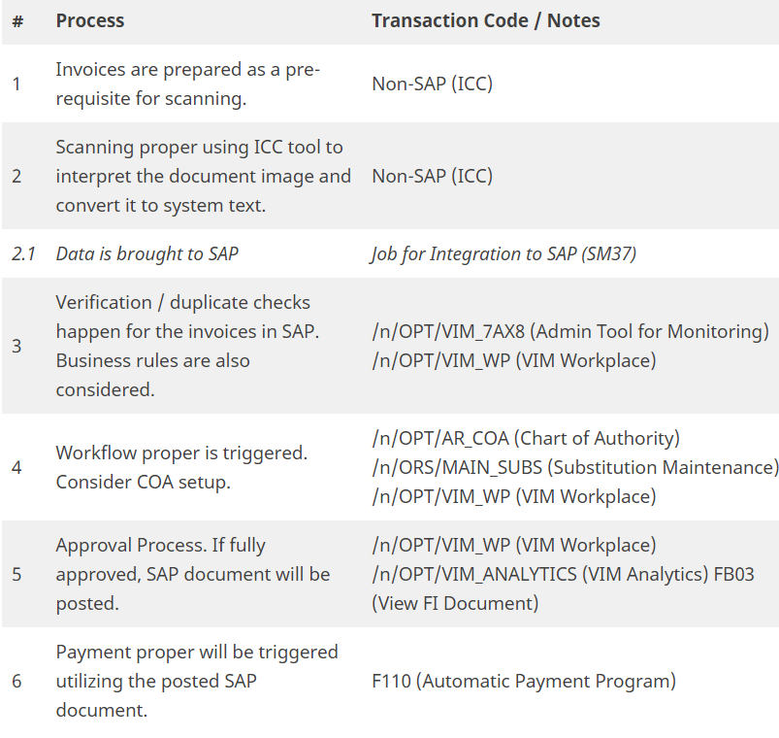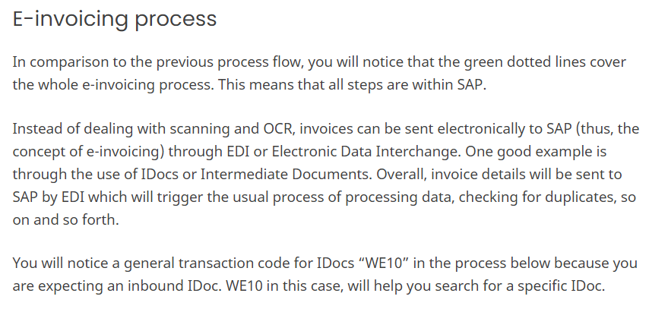

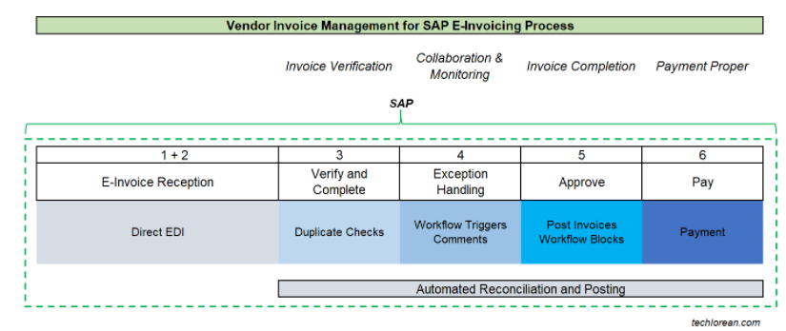

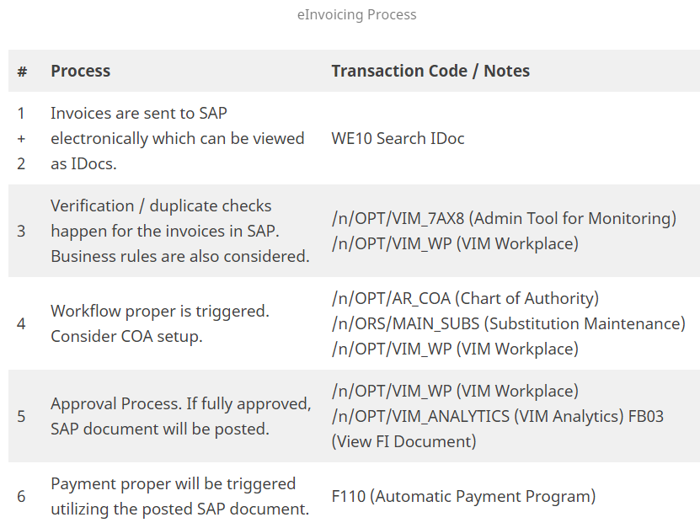

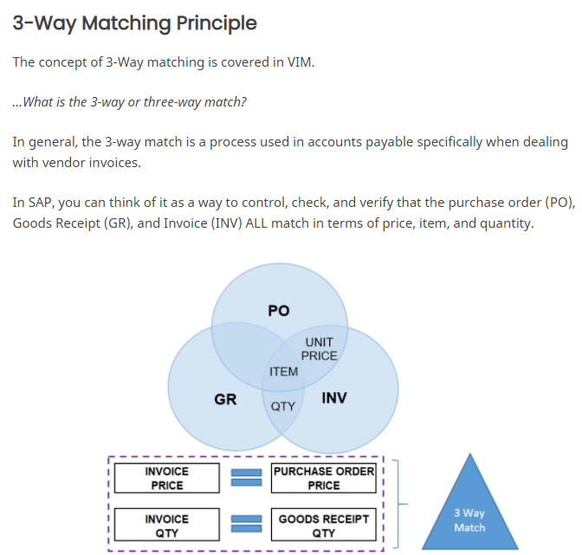

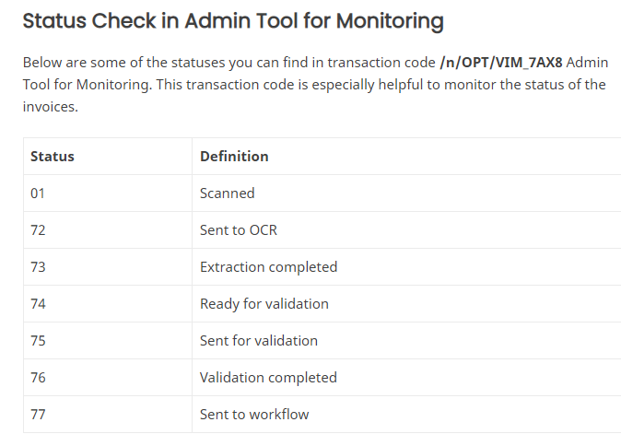

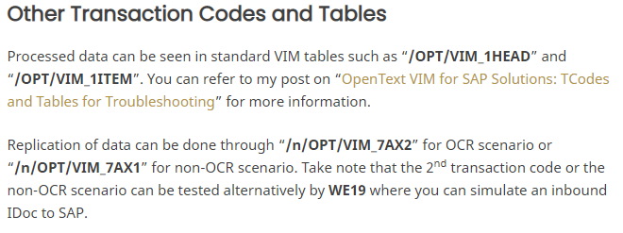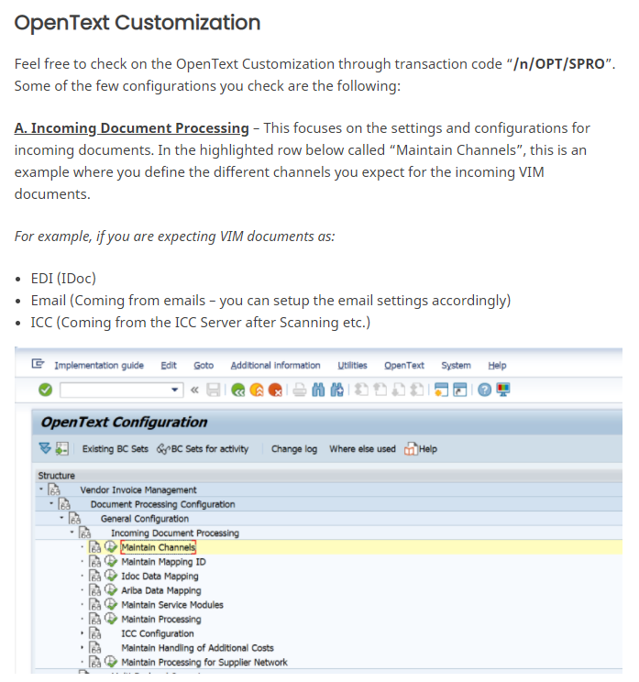

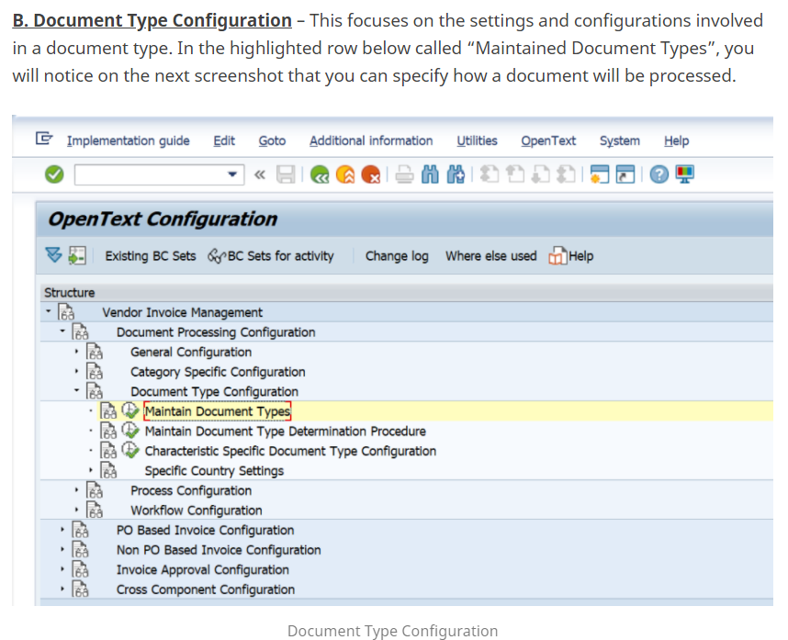

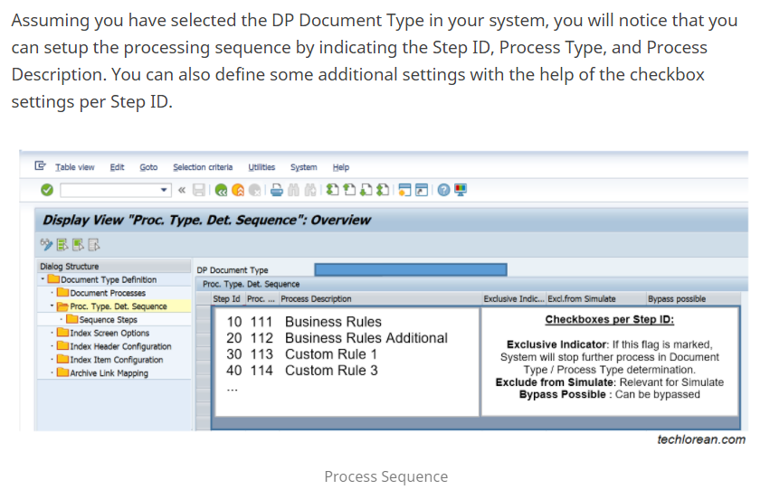

OPENTEXT VIM FOR SAP SOLUTIONS: TCODES AND TABLES FOR TROUBLESHOOTING

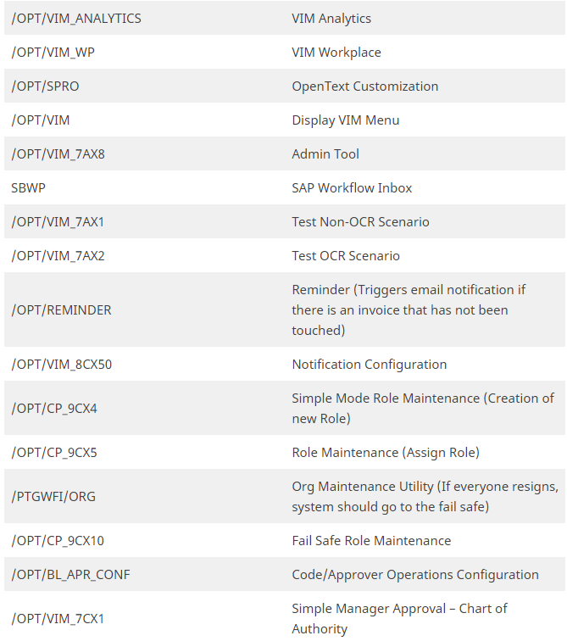

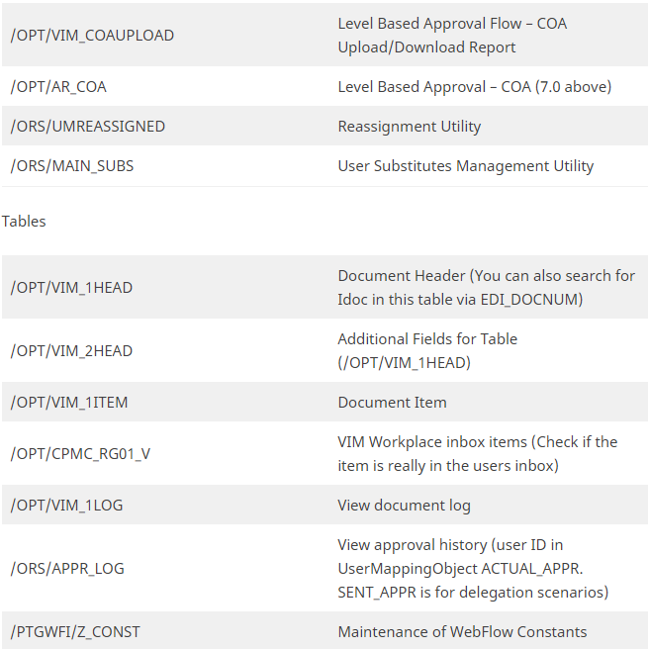

MM Steps

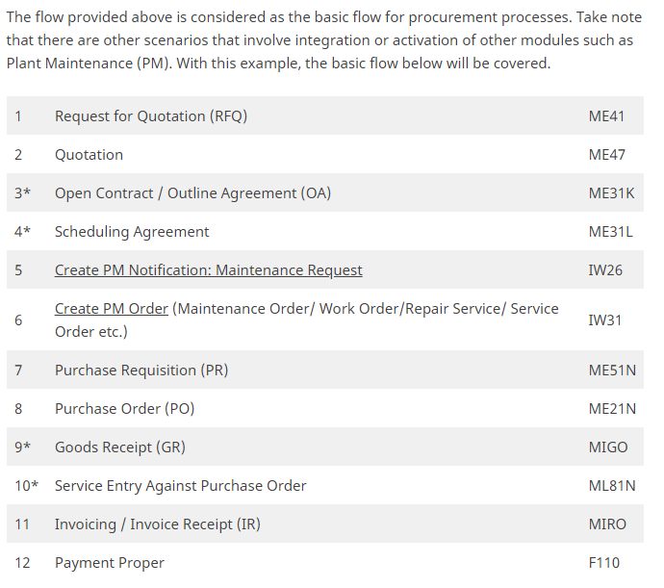

Resourceful websites

[Techlorean. – Life in Tech. SAP Consultant.](https://techlorean.com/) – Many basic courses with good contente

ABAP Cheat Sheet – IDOC &

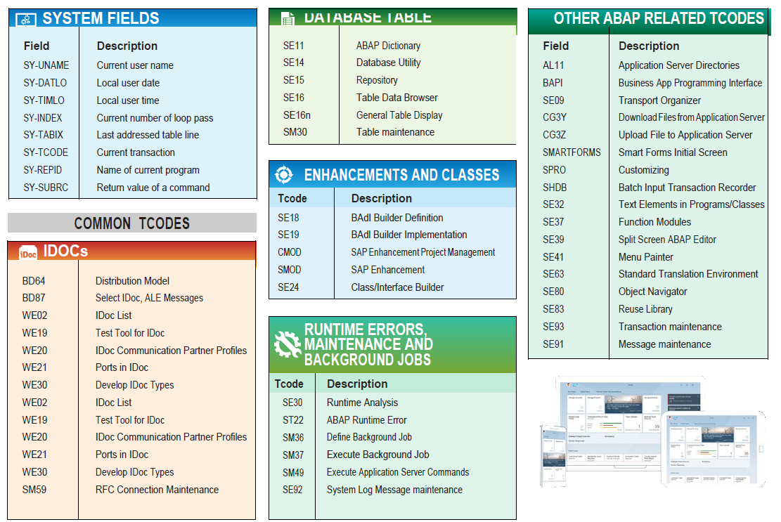

**Payments for Brazil**

Payments to Brazil for bar code and without bar code using Febraban CNAB 240, segments N and O starting from version 2020 on premise and cloud 2005

<https://blogs.sap.com/2020/08/31/utilities-and-tax-payments-in-brazil/>

**Fields by Country**

In the transaction OY17 is possible to check the length of many fields and all of them are related to localization.

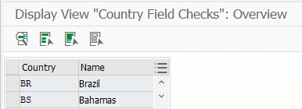

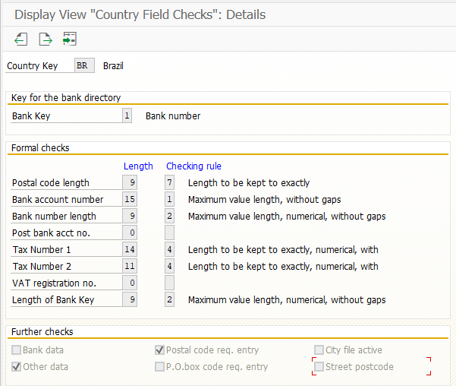

**HELP SAP – See FI**

Brazilian localization only – very good for AP and AR payments

<https://help.sap.com/saphelp_globext607_10/helpdata/en/97/dd032e5c08f74a8f45bce8c0f7ceb3/frameset.htm>

**SAPUI5 for Beginners**

<https://blogs.sap.com/2020/12/15/learning-sapui5-for-beginners/>

**Finance Tutorials by SAP**

[Task Tutorials (ondemand.com)](https://education.hana.ondemand.com/education/pub/s4/index.html?library=library.txt&show=group!GR_B06D29AAEF1CFBC#group!GR_38306E84FD587881) – with vídeos and manuals.

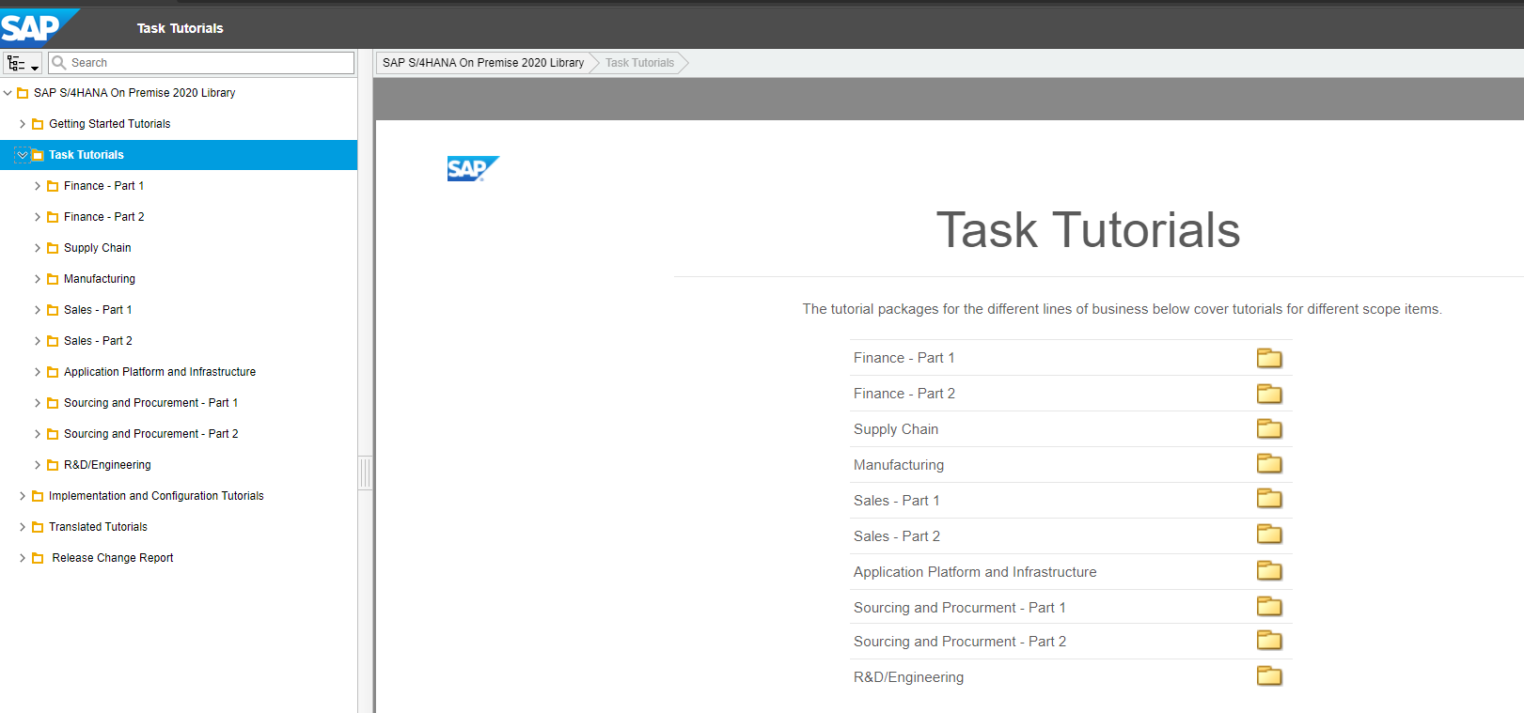

**Record to Report – Blogs from SAP**

[R2R Series Blog #1: Record to Report Blog Series Kick Off | SAP Blogs](https://blogs.sap.com/2021/08/04/record-to-report-blog-series-kick-off/)

Good financial subjects to study.

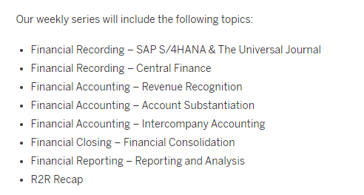

Information about Lockbox

[Lockbox Processing in SAP | SAP Blogs](https://blogs.sap.com/2020/07/05/lockbox-processing-in-sap/)

**Jobs in SAP**

A good way to know the steps or what job is doing is to check the variant that job is using. In order to do that click on the job name and click on the button “Step” below.

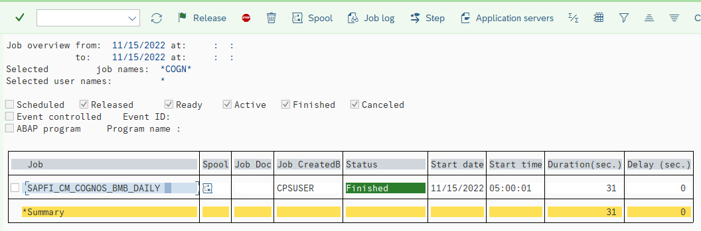

Click on the “Program name/command” line below…

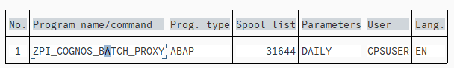

In the menu click on Goto 🡪 Variant

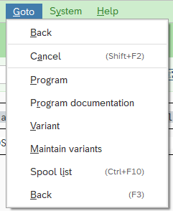

And this will show the variant with its filter applied.

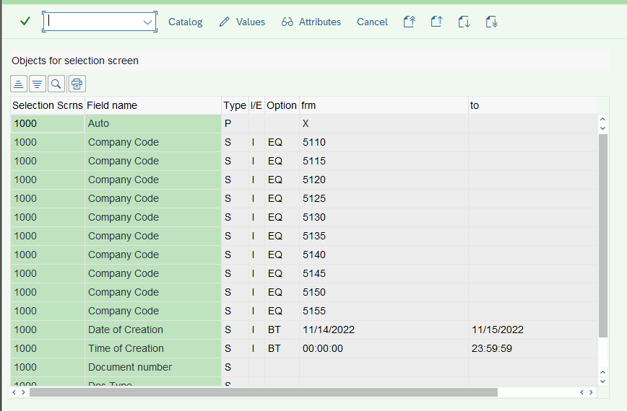

**/n in the command field**

This t-code /VIRSA/VFAT never worked on the command field and I didn`t know (so far) how to use without add this t-code in my favorites (the only way that I know).

 

But now I know that I can starting this t-code with /n in the beginning that will work. To be tested on Hana.



**Trading Partner**

Trading partner goes to table T880. Check how to create them on the system.

On ECC is like that 🡪 To create the trading partner code must go to customizing: SPRO 🡪 Enterprise Structure 🡪 Definition 🡪 Financial Accounting 🡪 Define Company or t-code OX15

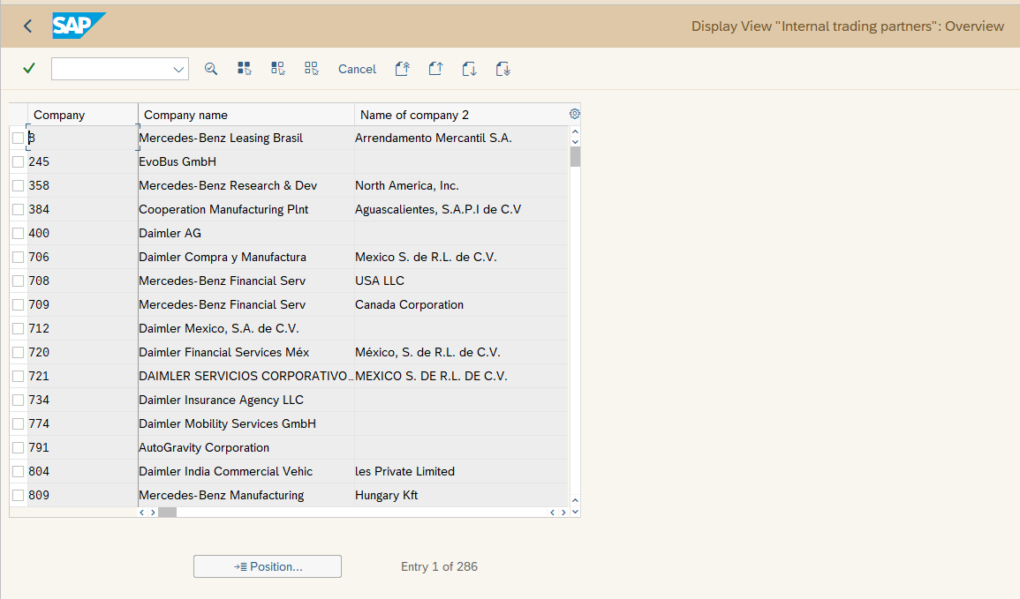

Open Item Management

To change an GL account from a “not open item” to an open Item management (OIM) go to on SE38 run the program FAGL_SWITCH_TO_OPEN_ITEM

The net amount of the OIM account to be must zero in all currencies and it is to be added on the fields in Account Data section, to run this t-code we need to use another account as “bridge” to make a posting 0.00 in Conversion section.

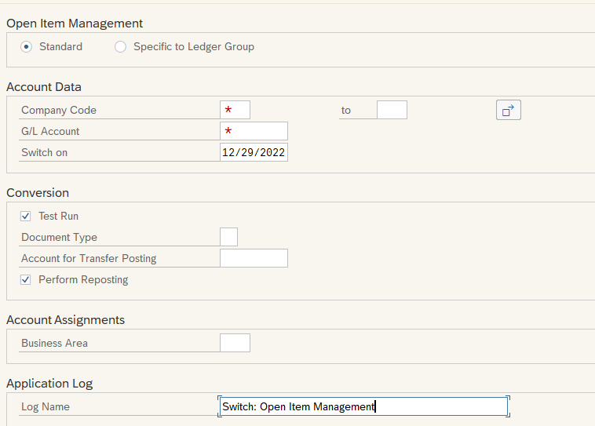

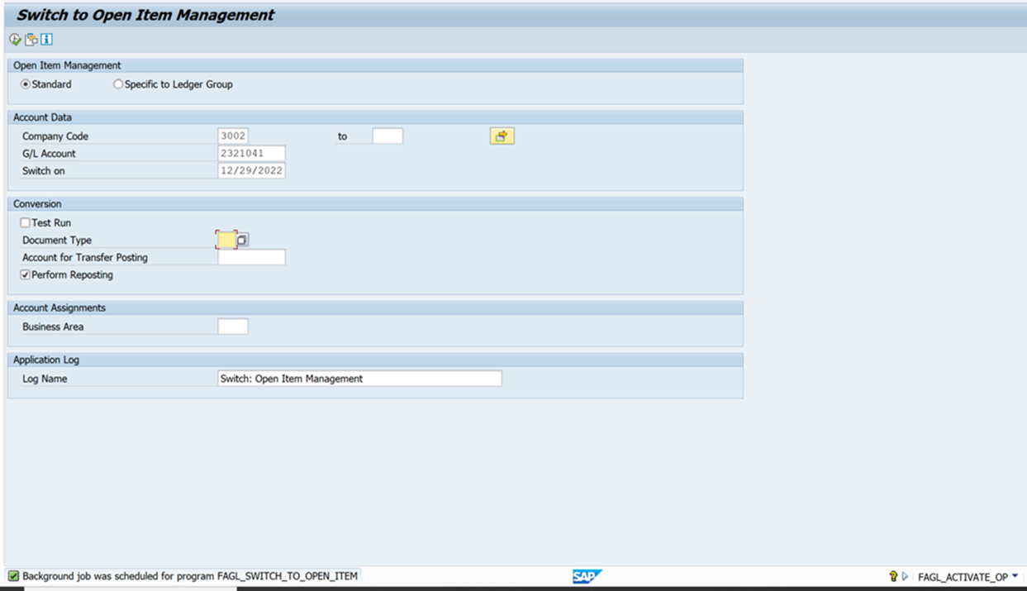

Chart of Accounts

Important steps to consider when create a GL account:

1. Check all GL accounts in 0DCS financial statement exist in the given Peg line or not
2. For B/S accounts check in KDH2 – PEG_ALL – GL account exist or not. If not, maintain under the peg line
3. For P&L accounts – check in KAH2 – PEG_CE – PL Account exist or not. If not, maintain under the peg line
4. For P&L accounts – check in KOH2-COPA_CE – PL account exists under a value field or not. If not, maintain accordingly

**Internal order**

To create an internal order one important step is to check table COAS and see the if the IO is not created yet. Important to check the name convention.



After that go to t-code KOH2 / KOH3

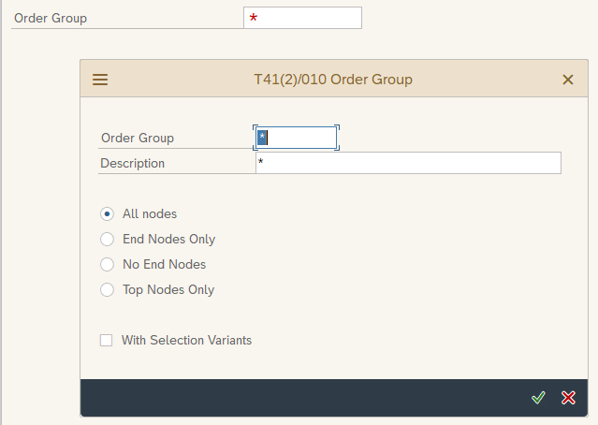

Check PPUS below

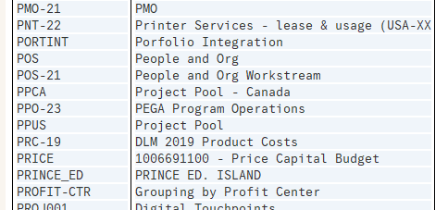



To add or create new structures like below to add the IO with.

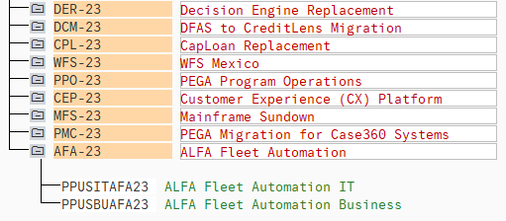

Estudar as transacoes OBBV and OBBU

In the t-code PFCG in order to SAP shows the t-code as below when you check for a role you need to click on that tiny icon on the left side of the printer icon.

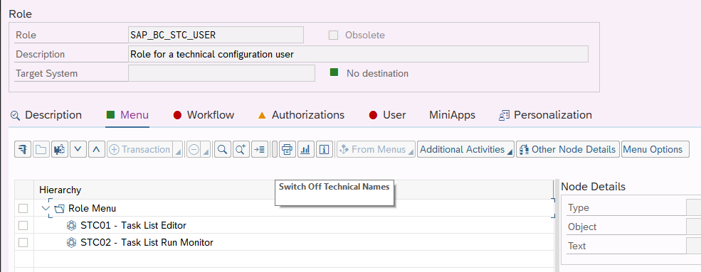

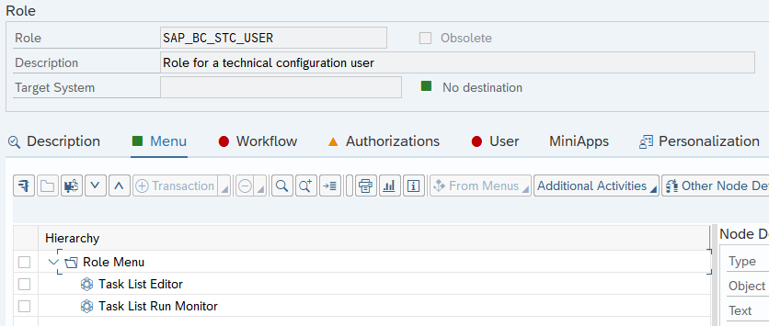

**Favorites**

To get someone’s favorites inside the system access table SMEN_BUFFC using SE16 with user ID.

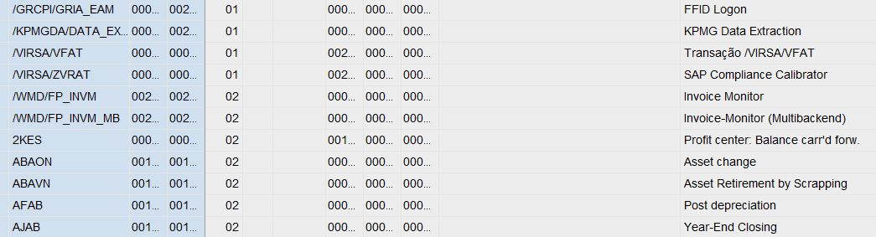

COPA / CO-PA Characteristics

When we use t-code KEDR in SAP to associate a profit center to a COPA characteristic and even a GL account we can do below.

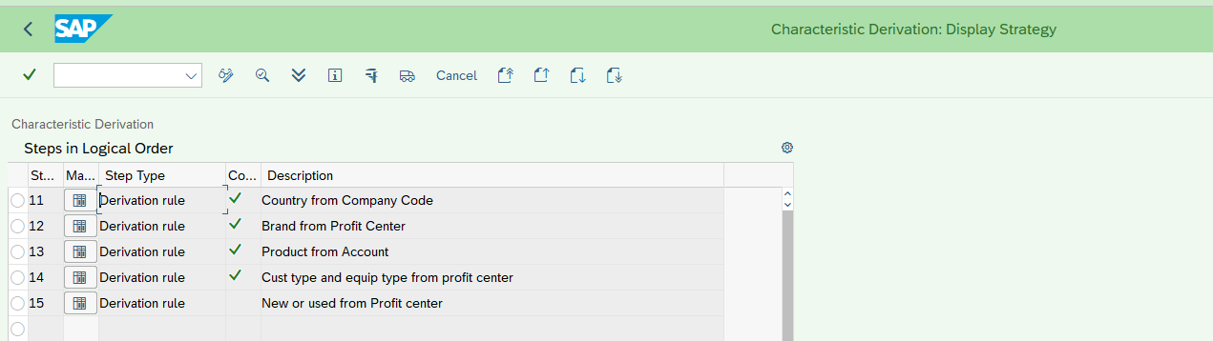

And a good way to test that is during the post (FB01 / F-01) the derivation button can be used to test that.

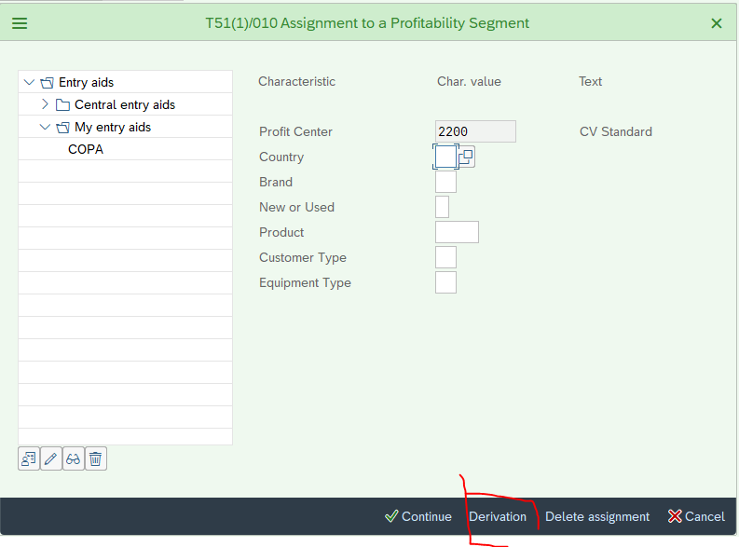

And after that an analyze can be done

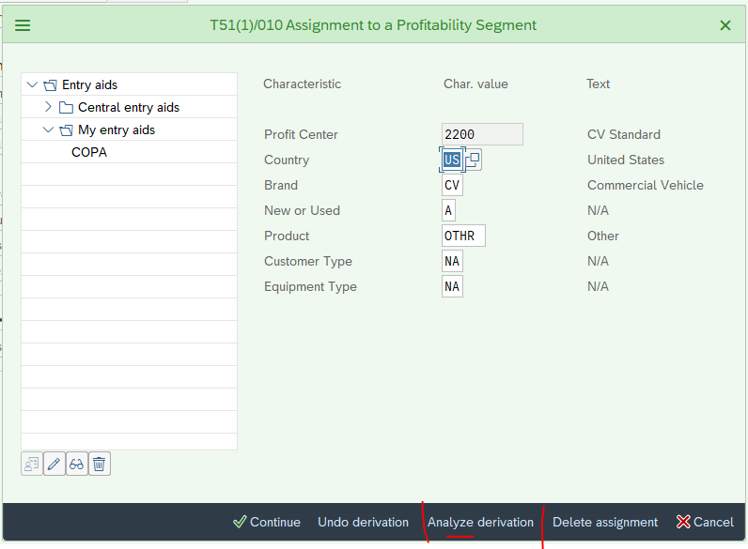

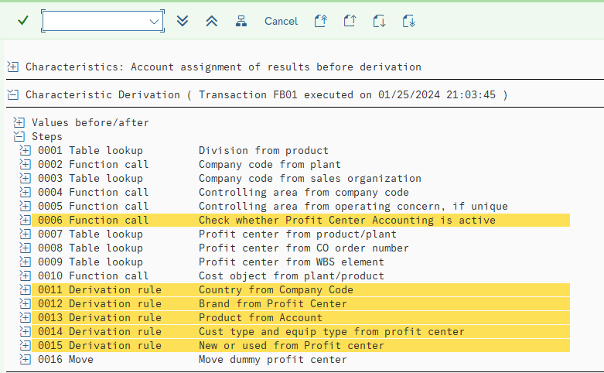

For a better search of roles than t-code PFCG is better do the way below:

T-Code SUIM – Roles by Complex Selection Criteria

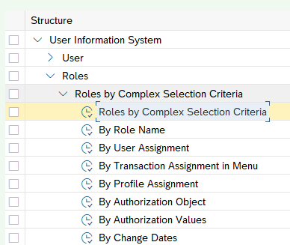

Sometimes the t-code keep the user of the last run

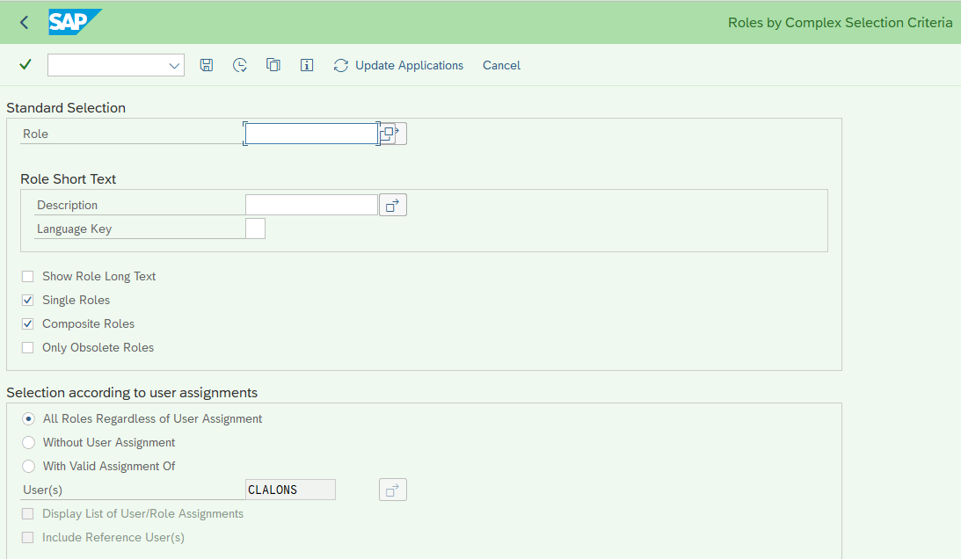

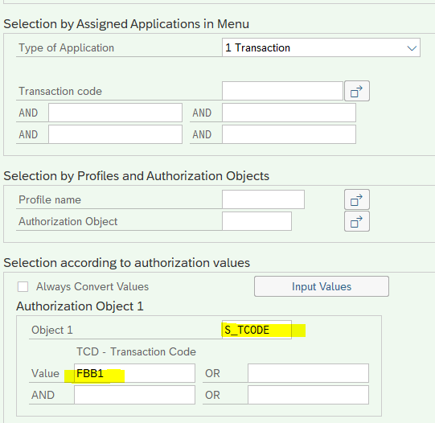

**Chart of Account**

When I was creating the GL accounts for Brazil I faced this error where the profitability segment was not there.

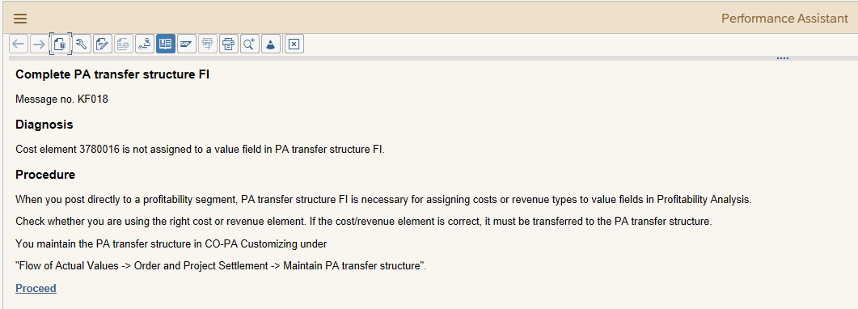

Click on “Proceed” above SAP took me to t-code KEI1

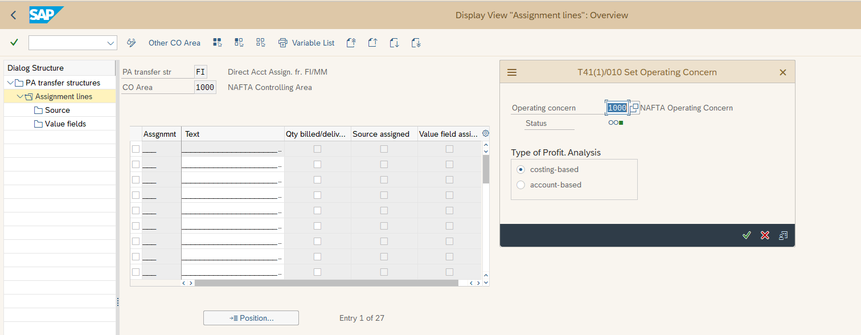

Then I need to check for FI structure.

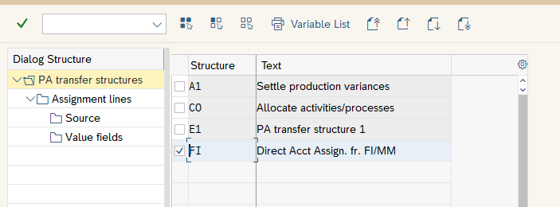

After some investigation I was able to find the correct assignment N17 below.

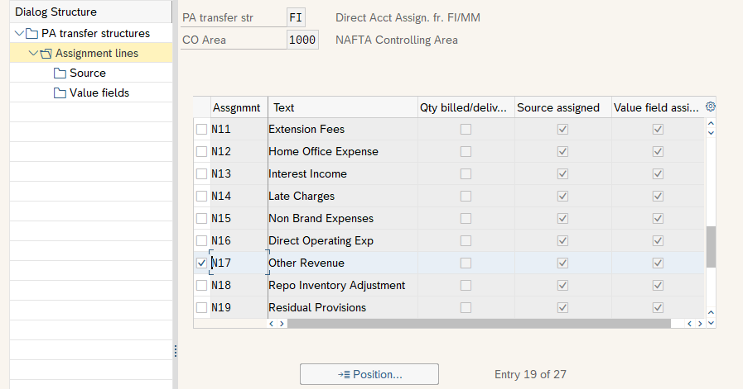

With that info I need to find out the group where I need to add the new P&L account.

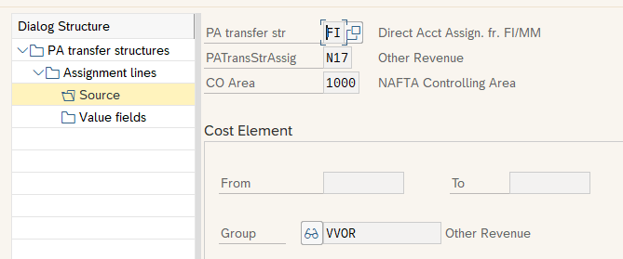

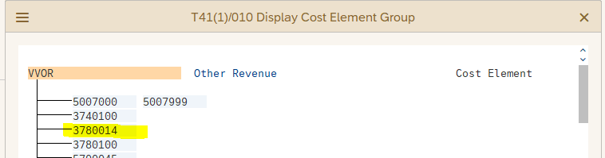

So I need to go to t-code KAH2 and do that

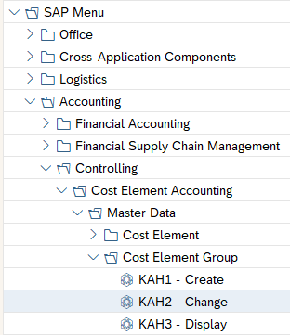

**Permanent Currency**

Some users from Canada would like to see their reports in CAD instead of USD in order to do that user needs to go to t-code RPC0 and as do as below:

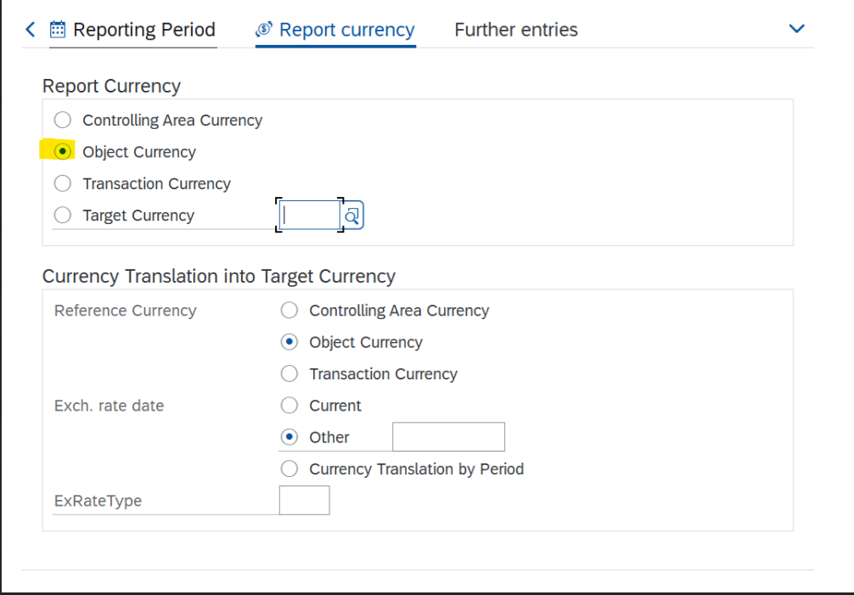

**Users active versus Users Inactive**

Run the 2 reports below with a detail for the second one. Sometimes the result is hidden!!! Scroll down to the end of the screen.

